**INSIGHT STREAM (NEWSREADING APP)**

**Naan Mudhalvan Project**

Submitted in partial fulfilment of the requirement for the award of

**BACHELOR OF COMPUTER SCIENCE**

Submitted By

**H SAI ROHITH-asunm110222201169**

**A BHARATH- asunm110222201144**

**M BHUVANESHWARAN- asunm110222201146**

**C MOHAN DASS- asunm110222201161**

**S SHYAM KUMAR- asunm110222201172**

UG DEPARTMENT OF COMPUTER SCIENCE

**DHARMAMURTHI RAO BAHADUR CALAVALA CUNNAN CHETTY’S**

**HINDU COLLEGE [SHIFT-II]**

“LINGUISTIC (TELUGU) MINORITY STATUS

CONFERRED BY THE GOVT.OF.TAMIL NADU”

Re-Accredited by NAAC –Affiliated to the University of Madras

Dharmamurthi Nagar, Pattabiram, Chennai-600072

**DECLARATION**

I am **H SAIROHITH** (NM Id:-**asunm110222201169**).Hereby declare that the **Nan Mudhalvan project** work title “**INSHIGHT STREAM(NEWSPAPER READING APP)”** submitted to the UG Department of Computer Science, **SMARTINTERZN** in partial fulfilment of the requirement for the award of Bachelor of Computer Science.

I am **A BHARATH** (NM Id:- **asunm110222201144**).Hereby declare that the **Nan Mudhalvan project** work title “**INSHIGHT STREAM(NEWSPAPER READING APP)”** submitted to the UG Department of Computer Science, **SMARTINTERZN** in partial fulfilment of the requirement for the award of Bachelor of Computer Science.

I am **M BHUVANESHWARAN** (NM Id:- **asunm110222201146**).Hereby declare that the **Nan Mudhalvan project** work title “**INSHIGHT STREAM(NEWSPAPER READING APP)”** submitted to the UG Department of Computer Science, **SMARTINTERZN** in partial fulfilment of the requirement for the award of Bachelor of Computer Science.

I am **C MOHAN DASS** (NM Id:- **asunm110222201161**).Hereby declare that the **Nan Mudhalvan project** work title “**INSHIGHT STREAM(NEWSPAPER READING APP)”** submitted to the UG Department of Computer Science, **SMARTINTERZN** in partial fulfilment of the requirement for the award of Bachelor of Computer Science.

I am **S SHYAM KUMAR** (NM Id:- **asunm110222201172**).Hereby declare that the **Nan Mudhalvan project** work title “**INSHIGH STREAM(NEWSPAPER READING APP)”** submitted to the UG Department of Computer Science, **SMARTINTERZN** in partial fulfilment of the requirement for the award of Bachelor of Computer Science.

**TABLE OF CONTENTS**

|  |  |
| --- | --- |
| **S.no** | **Contents** |
| **1.** | **INTRODUCTION** |
| **2.** | **OVERVIEW OF THE PROJECT** |
| **3.** | **SCOPE OF THE PROJECT** |
| **4.** | **FEATURES OF THE NEWS APP** |
| **5.** | **TECHNOLOGY STACK** |
| **6.** | **SOURCE CODE** |
| **7.** | **SCREENSHOT** |
| **8.** | **CONCLUSION** |

1. **INTRODUCTION**

The Insight Stream News App is an innovative mobile and web-based application designed to provide users with real-time news updates and personalized content from various sources across the world. In today's fast-paced world, staying informed with the latest news is crucial, and the Insight Stream News App aims to bridge that gap by delivering accurate, relevant, and up-to-date news in an accessible and user-friendly format.

This app brings together news from multiple domains such as politics, technology, entertainment, sports, and health, offering a seamless reading experience. Through advanced features like customizable news preferences, notifications for breaking news, and an intuitive user interface, the app ensures that users can easily stay updated on the topics that matter most to them. The app integrates various news APIs to fetch articles from trusted sources, providing a wide range of content to suit different interests.

Insight Stream is not a traditional newspaper reading app, but rather a feature that provides a live news feed of personalized search insights and important KPIs ¹. However, if you're looking for newspaper reading apps, here are some popular options

These apps offer a range of features, including personalized news feeds, offline reading, audio narration, and social sharing.

In a fast-moving world, staying updated with reliable news is more important than ever. INSIGHT-STREAM brings you the latest headlines, breaking news, and in-depth stories—all in one place.

✔ **Personalized News Feed** – Get stories tailored to your interests.  
✔ **News Alerts** – Be the first to know with real-time updates.  
✔ **Trusted Sources** – News from verified and credible publishers.  
✔ **Minimal & Distraction-Free Reading** – A clean, smooth, and immersive experience.  
✔ **Multi-Language Support** – Read news in your preferred language

**1.1 OVERVIEW OF NEWS APP**

* The Insight Stream News App is a modern, dynamic news platform designed to provide users with timely and relevant news content from around the world. It aims to deliver news articles, stories, and updates in real-time, curated from trusted sources across various categories such as politics, technology, health, sports, entertainment, and business. The app is built with an intuitive and user-friendly interface, making it accessible for users of all ages to stay informed effortlessly.
* At its core, the Insight Stream News App functions as an aggregator, pulling in news content from multiple APIs and trusted news outlets. It delivers personalized news streams based on user preferences and allows users to filter content by topics of interest, geographical region, or specific sources.

**1.2 SCOPE OF THE PROJECT**

* The scope of the Insight Stream News App project is focused on creating a comprehensive, real-time news platform that delivers up-to-date and personalized news content to users across multiple devices. The app will aggregate news from a wide range of trusted sources, offering coverage of various categories such as politics, technology, sports, entertainment, health, and more. It will allow users to customize their news feed based on their interests, ensuring they receive relevant content tailored to their preferences.
* The app will feature real-time news updates, push notifications for breaking news, and a user-friendly interface that is both mobile-responsive and desktop-compatible. Users will be able to search for specific articles, filter news by categories, and share content across social media platforms.
* The project scope also includes integrating external news APIs to ensure the app pulls content from multiple sources and ensures the accuracy and freshness of the information.

**1.3 FEATURES OF THE NEWS APP**

The Insight Stream News App is designed to offer a dynamic and user-friendly platform for accessing real-time, personalized news content. The app incorporates various features that enhance the user experience and provide them with timely, relevant, and accurate news updates.

**1. Real-Time News Updates:**

The app delivers live, up-to-date news from around the world, keeping users informed about the latest happenings in politics, technology, sports, entertainment, business, and more. This ensures that users always have access to the most current and relevant news.

**2. Personalized News Feed:**

Users can customize their news preferences based on their interests, such as topics (e.g., sports, politics, health), regions (e.g., local, international), or specific news sources. This tailored feed allows users to view only the content that matters most to them.

**3. Article Search and Filters:**

Users can search for specific articles or topics by keywords, and filter results based on categories, date, or relevance. This makes it easy for users to find exactly what they are looking for, saving time and enhancing the overall user experience.

**4. Interactive News Categories:**

The app organizes news articles into various categories like “Top Stories,” “Breaking News,” “Sports,” “Technology,” and “Health,” among others. This categorization makes it easier for users to quickly navigate to the type of content they are interested in.

**5. Push Notifications for Breaking News:**

The app sends real-time alerts and notifications about breaking news, important updates, or news events based on the user’s preferences. This feature ensures that users never miss critical news, regardless of where they are.

**2.TECHNOLOGY STACK**

The Insight Stream News App utilizes a robust and modern technology stack to ensure high performance, scalability, and user-friendly functionality. The app is developed with both the frontend and backend technologies that ensure seamless integration and a smooth user experience across various platforms

**2.1 FRONTEND TECHNOLOGIES**

* HTML
* CSS
* JAVA SCRIPT
* REACT

The Insight Stream News App leverages a modern set of frontend technologies to deliver an interactive and seamless user experience. At the core of the app is **HTML**, which provides the basic structure and layout of the web pages, ensuring that all content, such as articles, images, and videos, is displayed in an organized manner. The design and styling of the app are handled by **CSS,** which enables responsive layouts that adjust smoothly across various devices like desktops, tablets, and smartphones. To enhance user interactivity, **JAVASCRIPT** is used to manage dynamic content and real-time data updates, allowing the app to fetch and display the latest news without reloading the page. Additionally, the app utilizes **REACT.JS**, a powerful JavaScript library, to build a component-based architecture that promotes efficient rendering and smooth user interactions. React.js helps in managing the app's state and enables real-time updates of news content. With these technologies, the app offers a responsive, fast, and user-friendly interface, ensuring a high-quality experience for users across different platforms.

**2.4 API INTEGRATION**

* NEWS APIS

In the Insight Stream News App, API integration plays a crucial role in fetching real-time news content from external sources, providing users with up-to-date and relevant articles. One of the main APIs used in this app is a **NEWS API**, which aggregates news from various sources worldwide, delivering content in a structured format. By integrating these APIs, the app can seamlessly fetch news articles based on specific categories such as technology, sports, entertainment, and politics.

**3. SOURCE CODE**

**1.index.html**

<!DOCTYPE html>

<html lang="en" data-bs-theme="dark">

  <head>

    <meta charset="utf-8" />

    <link rel="icon" href="%PUBLIC_URL%/news.png" />

    <meta name="viewport" content="width=device-width, initial-scale=1" />

    <meta name="theme-color" content="#000000" />

    <meta

      name="description"

      content="Web site created using create-react-app/>

    <link rel="apple-touch-icon" href="%PUBLIC_URL%/logo192.png" />

    <link rel="manifest" href="%PUBLIC_URL%/manifest.json" />

    <!--

      Notice the use of %PUBLIC_URL% in the tags above.

      It will be replaced with the URL of the `public` folder during the build.

      Only files inside the `public` folder can be referenced from the HTML.

      Unlike "/favicon.ico" or "favicon.ico", "%PUBLIC_URL%/favicon.ico" will

      work correctly both with client-side routing and a non-root public URL.

      Learn how to configure a non-root public URL by running `npm run build`.

    -->

    <title>Insight Stream</title>

  </head>

  <body>

    <noscript>You need to enable JavaScript to run this app.</noscript>

    <div id="root"></div>

  </body>

</html>

**Index.css:**

@import url("https://fonts.googleapis.com/css2?family=Inter:wght@300&display=swap");

body {

  margin: 0;

  font-family: "Inter", sans-serif;

  background-color: rgb(36, 39, 41) !important;

}

::-webkit-scrollbar {

  width: 3px;

}

::-webkit-scrollbar-thumb {

  background-color: #464b50;

}

**Index.js**

import React from "react";

import ReactDOM from "react-dom/client";

import "./index.css";

import "bootstrap/dist/css/bootstrap.min.css";

import { RouterProvider } from "react-router-dom";

import appRouter from "./router/appRouter";

import { Provider } from "react-redux";

import { store } from "./store/store";

const root = ReactDOM.createRoot(document.getElementById("root"));

root.render(

  <Provider store={store}>

    <RouterProvider router={appRouter} />

  </Provider>

);

**2.manifest.json**

{

  "short_name": "React App",

  "name": "Create React App Sample",

  "icons": [

    {

      "src": "favicon.ico",

      "sizes": "64x64 32x32 24x24 16x16",

      "type": "image/x-icon"

    },

    {

      "src": "logo192.png",

      "type": "image/png",

      "sizes": "192x192"

    },

    {

      "src": "logo512.png",

      "type": "image/png",

      "sizes": "512x512"

    }

  ],

  "start_url": ".",

  "display": "standalone",

  "theme_color": "#000000",

  "background_color": "#ffffff"

}

**4. Screenshot**

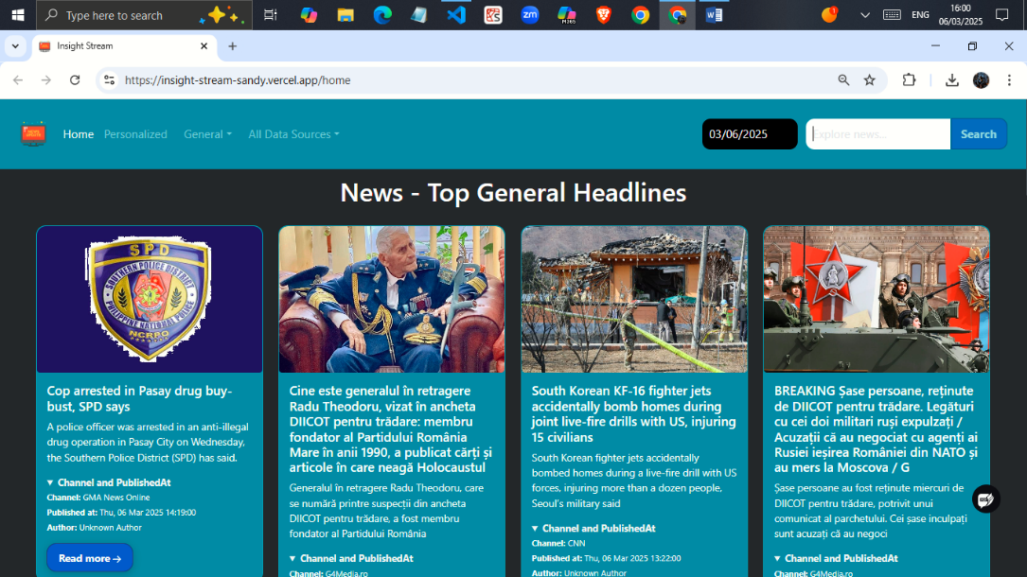

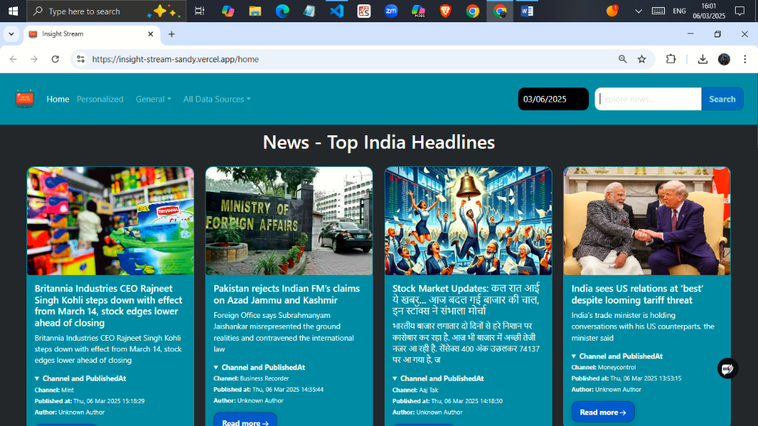

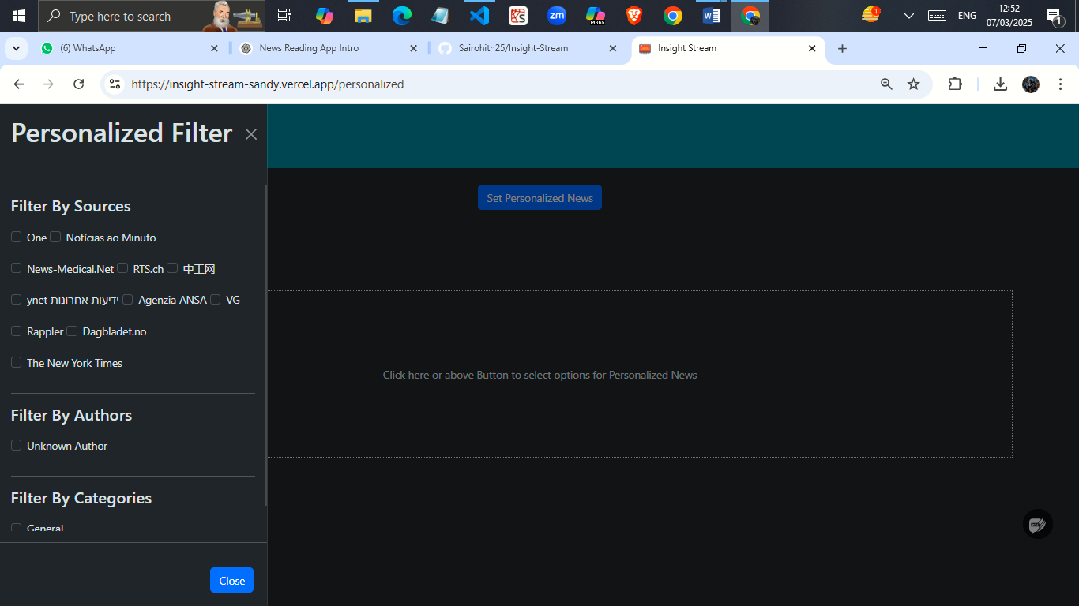

**Project structure:**

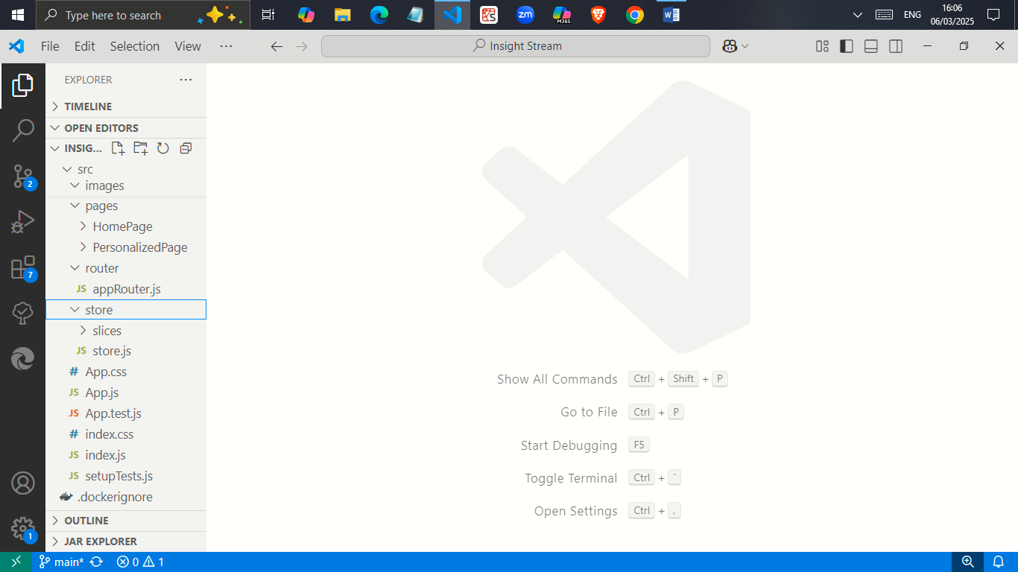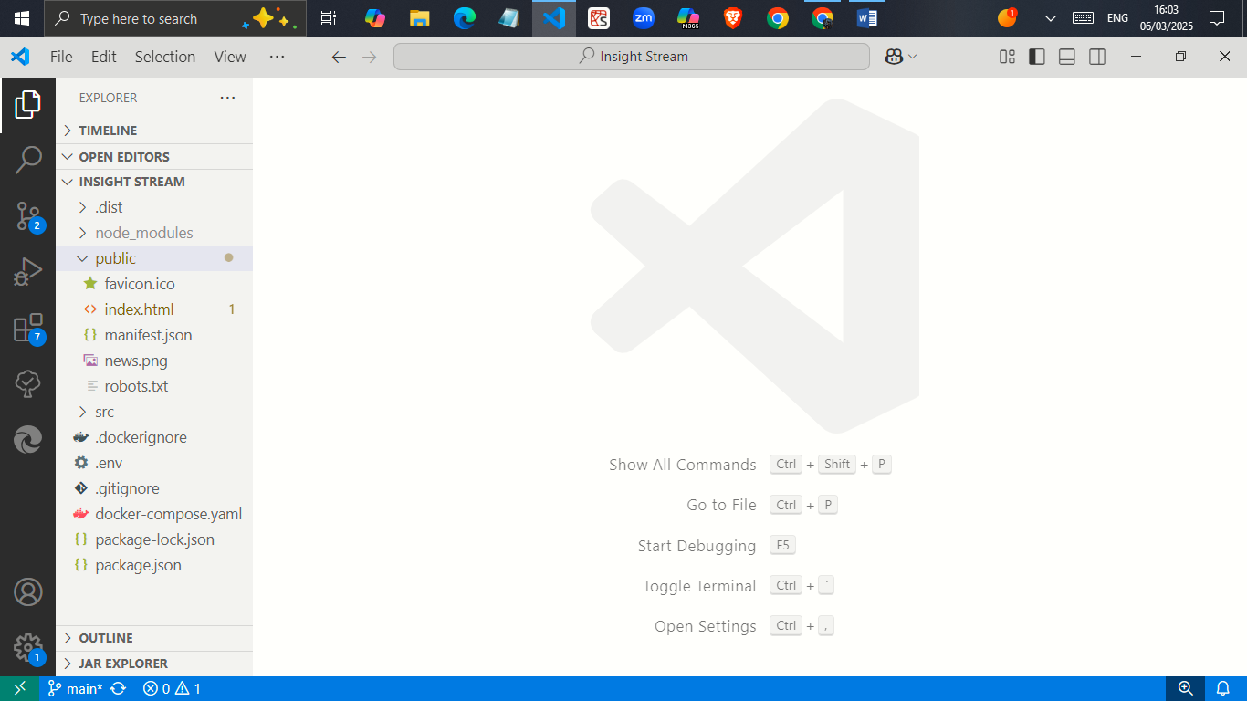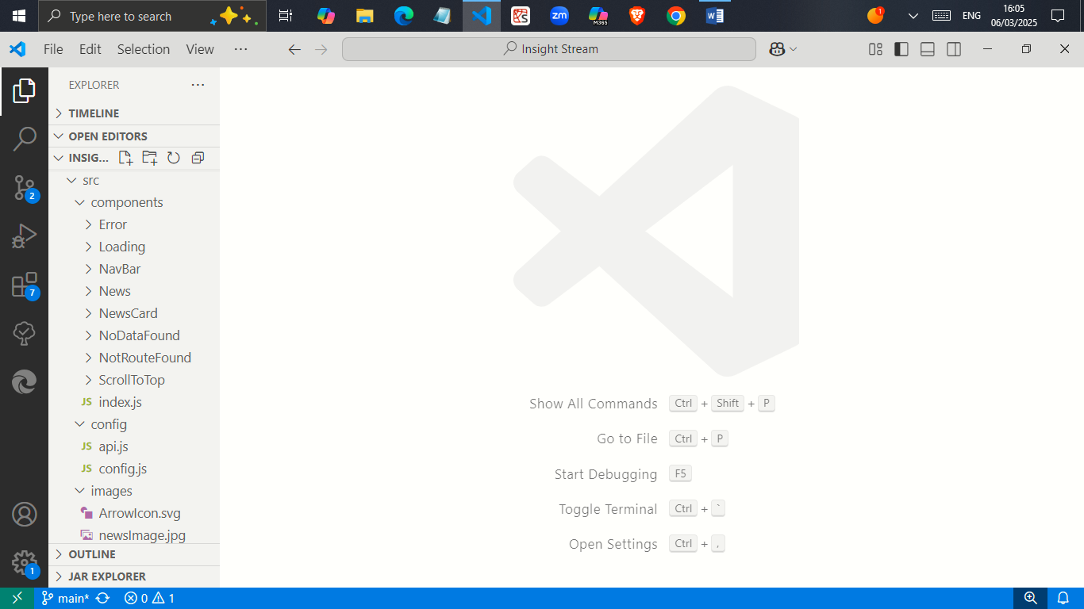

**CONCLUSION:**

In today's fast-paced world, staying informed has never been easier with **INIGHT-STREAM**. Our smart news reading app curates the latest headlines, breaking news, and in-depth stories from trusted sources, all in one place. Whether you're interested in politics, technology, sports, entertainment, or global affairs, **it** delivers personalized news tailored to your preferences. With real-time updates, an ad-free reading experience, and multi-language support, you can stay ahead of the curve anytime, anywhere. Download **the** today and transform the way you consume news—fast, reliable, and designed just for you!